Brooklyn torah gazette
For parshas bereishis 5783
Volume 7, Issue 5 (Whole Number 312) 27 Tishrei 5783/ October 22, 2022
Printed L’illuy nishmas Nechama bas R’ Noach, a”h

For a free subscription, please forward your request to keren18@juno.com
Past stories can be found on the website ShabbosStories.com

A Letter to Hashem
By Rabbi Uri Lati

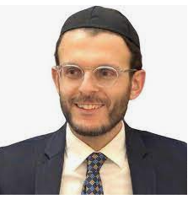
Rabbi Uri Lati

In the town of Mir, which is on the border between Poland and Lithuania, there was a girl that was orphaned from her father at a very young age. Because she was orphaned from her father, there was no one to support the household other than her and her mother. So, she worked as a librarian, bringing in whatever she could to the house.
But it was very hard, seeing all her friends getting married at a young age, many of them having children. She wasn’t able to get married because no one was supporting her. There was no father to pay for her wedding. No father to pay for any expenses.
But she never lost hope. She always prayed to Hashem, “I want to marry a talmid chacham (Torah scholar).” But after a few years of her dream not coming true, she decided to write a letter to Hashem.
She worked in the library and at a lunch break, she took a piece of paper, and wrote:
“Father in Heaven, I want to get married to a talmid chacham. You, Hashem, take care of all the expenses. You have a lot of money. There's no shortage in your bank. There's no recession. There's no inflation. Hashem, you take care of all the expenses. This is what I want.” And she signed it, your beloved, committed, dedicated daughter, Shayna Miriam.
She signed it, put it in the envelope and then went outside of the library. It was a very cold, windy day, and so she stood waiting for the wind to pick up her letter. Finally, as a gust of wind rushed past her, she released the letter from her hand and it went flying. She addressed it on the outside … Aviv She’bashamayim (My Father in Heaven). She didn't think more about it.

Letter Discovered Weeks Later
A few weeks later, there was a yeshiva student walking outside of yeshiva. He looked on the floor and saw there's an envelope. It read, “Father in Heaven.” Now, usually, you’re not supposed to pick up anybody's mail. But he couldn't help it. Who's writing a letter to Hashem? I got to figure out who this is, he said to himself.
So, he opened it up and he read it.
He began crying, seeing the sincerity in her words, and realizing that she had probably spilled a lot of tears when writing this letter. He ran to his Rosh Yeshiva and said, “I have to find out who this girl is.” They looked into it, and found out where the girl was living. Weeks later, they got married. The name of the boy was Rav Yitzchak Yechiel Davidowitz. He was the Rosh Yeshiva of Minsk, the rebbe of Rav Yaakov Kamenetsky, Rabbi Yaakov Yitzchak Ruderman, and Rav Avraham Kalmanowitz.
The girl’s dream came true. She married a talmid chacham.
What is the takeaway from this story?
The girl was so sincere in her letter because she knew that Hashem could give her whatever she wanted. There is no shortage for Hashem. We can make Hashem little sometimes, putting Hashem in a box. Hashem is only able to give me this, so I won’t request this. But don't put Hashem in a box. Whatever we want, Hashem can give us. The problem is us. He's not lacking anything; we're lacking. We're lacking the belief that Hashem can give us anything.
She wrote a letter to Hashem. The sincerity in her words, in her prayer, was beautiful. Hashem is able to give us whatever we want. We stand in front of Hashem and ask Him for our needs. Believe that Hashem can give it to you. Believe that no matter what, we can start everything afresh, everything clean. That's the power of teshuvah. You can come back to your Creator. Come back to your Father and realize that Hashem can give us anything.

Reprinted from the Parshat Vayelech 5782 email of the TorahAnytime Newsletter compiled and edited by Elan Perchik.

After 500 Years,
Closing the Circle
By Esther Malka Astruc

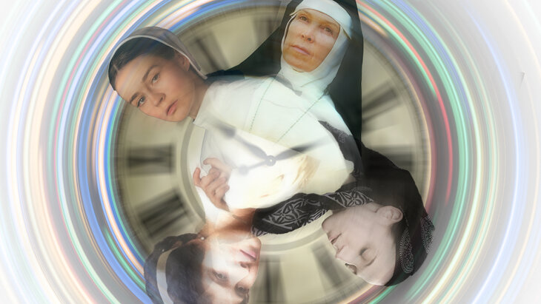
My Jewish grandmother from 15 generations ago died in a Catholic convent as a nun. My spiritual return to Judaism began with dreams of becoming a nun.

I didn’t go searching for Violante Fernández Gómes, my grandmother from 15 generations ago. The document with her story, along with our family tree listing my grandmother all the way back to Violante, appeared suddenly out of nowhere, sent to me by a distant cousin.
It may sound preposterous to keep track of fifteen generations of grandmothers, but when you convert to Judaism not knowing you had any Jewish ancestors, one from 15 generations ago will do just fine.
Her story also happens to be incredible.
What does an ousted, closeted Jew who is kicked out of the palace in ignominy do? She went to live in a convent and became a nun.
Violante Fernández Gómes was born to Victoria and Pedro Luis, descendants of forcibly converted Jews. She was stunning in her beauty, and the Prince Luis, son of King Manuel, insisted on marrying her, even though she was known to be a “New Christian” — the daughter of conversos (Jews of Spain and Portugal who were forcibly converted to Catholicism in the time of the Inquisition).
She bore him two sons, Antonio and Juan, and life in the palace of the prince was great for a good many years — until something happened.

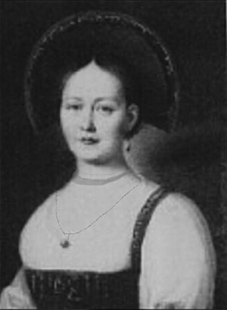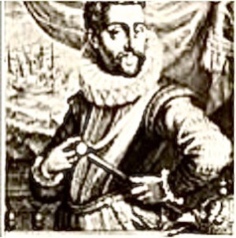
Violante Fernández Gómes and her son Juan

Exactly what transpired 500 years ago is a mystery we’ll probably never know. All that the accounts tell us is that “something that was discovered, pertaining to her [Jewish] blood, caused her to be banished from the palace.”
What does an ousted, closeted Jew who is kicked out of the palace in ignominy do? She went to live in a convent, home of Catholic nuns, and became one. Not long afterwards she died there, surrounded by the symbols and rites of Catholicism.
I like to imagine that Violante, in spite of her situation, remained true to the God of the Jewish people in her heart, praying for her children to someday return to their people, to their true faith.
In the end, her son Juan, who sailed to Mexico, married a Jewish woman, Catalina López de Nava, whose family secretly adhered to the Jewish customs. Their descendants also kept the Jewish traditions alive in secret, in their new home in what is now Lagos de Moreno in Jalisco, México.
Many of their descendants were caught by the Inquisition and tragically burned at the stake, sanctifying G-d’s Name in Mexico City.
Violante must have cried copious tears for her son Antonio, for he was taken to be raised in the church to be a Prior, a type of clergyman. But even he managed to marry a woman, Ana Barbosa, who was descended from Jews — although he remained a Catholic all his days.
Antonio, briefly king of Portugal, was ousted by Phillip II, King of Spain, and fled for his life to France, from where my great grandmother, Emilie, his descendant, emigrated to the United States in 1900, and where I was later born.

Discovering Judaism
And now we have another mystery. Why did my father, who wasn’t a Christian, decide to put me into a Catholic convent school? My Catholic nanny, Marie, who cared for me after my mother’s passing, was very pleased at this turn of events. For two years in my childhood, I was surrounded by the nuns, statues and symbols of the Catholic church.
Because the Catholic nanny was almost like a second mother to me, by the time I was 12 I had decided to follow in her footsteps and become a Catholic. I even had hopes of growing up to be a nun like the sisters of the convent school I had attended.
My Catholic nanny was like a second mother to me and by the time I was 12 I had decided to follow in her footsteps and become a Catholic.
But then everything suddenly changed.
A Jewish girl, Leah, came to our town and became my best friend. She said, “We Jews don’t believe in a ‘god’ that’s a person. Our G-d isn’t physical at all. He has no body, you can’t see Him, and He’s All-Powerful. He’s above this physical world. He’s not a human and never was a human. He is above everything.”
This shocked me. There were people in the world who didn’t believe in Christianity? Who believed in a G-d that was purely spiritual, invisible, and above everything? This got my attention.
It took me some time to wrap my brain around it— but when Leah brought me to her synagogue, I could somehow feel her “invisible God”. And this was the beginning of a new journey in my life.
Meanwhile, Leah noticed that I was somehow drawn to her people and their way of life, and without really thinking about it much, she began teaching me everything she knew from having grown up in a traditional synagogue. She saw my interest in learning Hebrew, loaned me all her textbooks from her shul’s after-school program, and I learned to read Hebrew and some basic vocabulary.

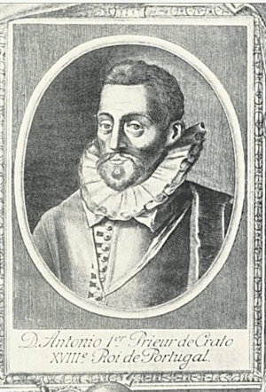
Her son Antonio Gómes Avis who was briefly king of Portugal

Leah’s family were very warm, and her parents — perhaps recognizing the needs of a girl orphaned of her mother — showed me a great deal of love and acceptance. This, coupled with the acts of kindness that I saw being done for others by the members of Leah’s synagogue, greatly influenced my break with Catholicism and drew me towards the Jewish people.
When I graduated high school and went to college in Wisconsin, I made many Jewish friends, some of whom were on a path to reconnect to their Jewish heritage. Seeing my interest in Judaism, they brought me with them to spend Shabbat at the home of an Orthodox Jewish family.
This amazing experience transported me to another world, to a spiritual oasis called “Shabbat”. I was hooked.
My friends told me that as the Rabbi’s guests, we should be careful not to do anything to “break Shabbat.” So, for the first time in my life, I experienced what keeping Shabbat was like. This amazing experience transported me to another world, to a spiritual oasis called “Shabbat”. I was hooked.
Needless to say, my plans to join a convent had been left far behind me.

How Do I become Jewish?
But how to become Jewish? At this point, G-d, who had been leading me step by step in the right direction, caused me to meet and befriend Sarah, who had just converted to Judaism. She told me her whole story, explaining exactly what the conversion process entailed.
I confessed to her that I wasn’t Jewish and had been confused as to how to proceed. With her amazing support—for which I’m eternally grateful— after a period of study the day came when I stood before a Beit Din, a tribunal of Orthodox rabbis, and finally became a Jew.
All this occurred without me knowing anything of my Jewish ancestors.
Only many years later, after I married and my children had grown, did my daughter and I start tracing our family tree, and we were shocked to discover ancestors with Jewish-Spanish names. Suddenly we were Spanish! This was bewildering enough— but at the same time, I started to feel as though my ancestors were here with me, driving me to discover more about my family, and to help others who have Spanish descent to come closer to their Jewish heritage.
She died in a convent — and I started out in a convent, with dreams to become a nun — but then turned around and became a Jew!

The Widow of My Distant French Cousin
Then I received a link to the document with Violante’s story from the widow of my distant French cousin. When I read it, I was overwhelmed by her story. It seemed like something out of a novel. She was a converso and married the king’s son? She was banished from the palace and died in a convent as a nun?
But even more than that, I was struck by one very interesting detail: Where Violante’s story ended, mine began. She never had the chance to return to her people and live openly as a Jew. She died in a convent — and I started out in a convent, with dreams to become a nun — but then turned around and became a Jew!
The Divine orchestration was just too powerful to ignore.
My Rabbi told me, “Maybe you are finishing your ancestor’s mission in this world.” I suspect he’s right. I can imagine Violante praying from the depths of her heart for her descendants to return home.
It seems that G-d has heard her tears and after 15 generations brought our family back.

Reprinted from the October 6, 2002 website of aish.com
Jewish Life Goes On, Helping Hurricane-Stricken Venice, Fla., Cope With Disaster
By Yaakov Ort
An emotional Yom Kippur, a Jewish funeral, and Sukkot preparations

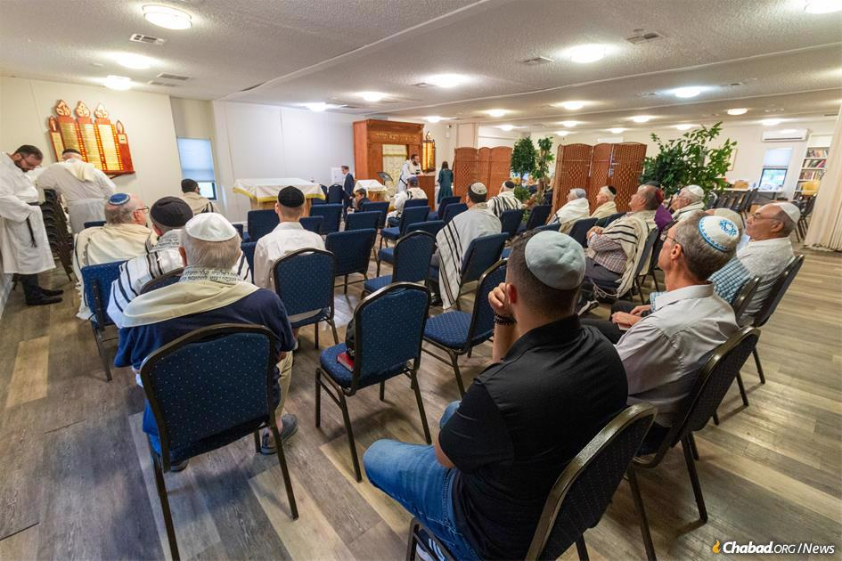
Congregants gather for Kol Nidre services at Chabad of Venice, Fla. (Credit: Chabad.org/Tzemach Weg)

VENICE, Fla.—Even as the aid efforts continue and the rebuilding work begins for those whose lives were uprooted by Hurricane Ian a little more than a week ago, Jewish life has not stopped at Chabad of Venice, Fla.—bringing a much-needed sense of normalcy, continuity and hope to many who have never experienced a natural disaster of these proportions.
In recent days, from emotionally-charged Yom Kippur services to a sorrowful funeral and preparations for the joyous festival of Sukkot, Jewish life in Venice goes on with the help of Chabad directors Rabbi Sholom Ber and Chaya Rivka Schmerling.

Much of the neighboring area, including outside the Chabad center, was still flooded before the holiday. (Credt: Chabad.org/Tzemach Weg)

The following pictures were taken for Chabad.org by photographer Tzemach Weg, who flew down to Florida soon after the hurricane struck the state and has served as one of many volunteers helping with rescue and relief efforts.
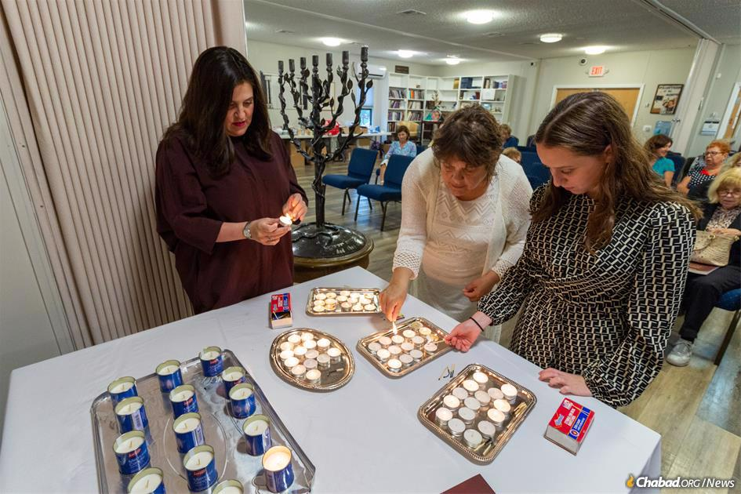
Women light candles at the start of the holiday. (Credit: Chabad.org/Tzemach Weg)

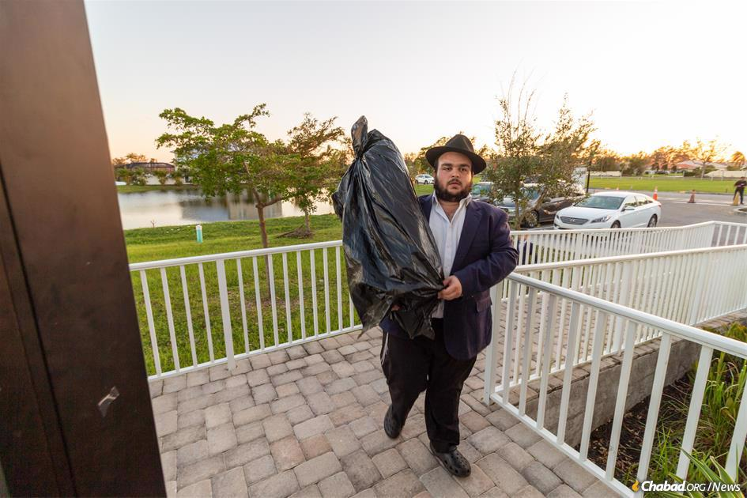
A Torah scroll taken to safety during the hurricane is returned to the synagogue. (Credit: Chabad.org/Tzemach Weg)
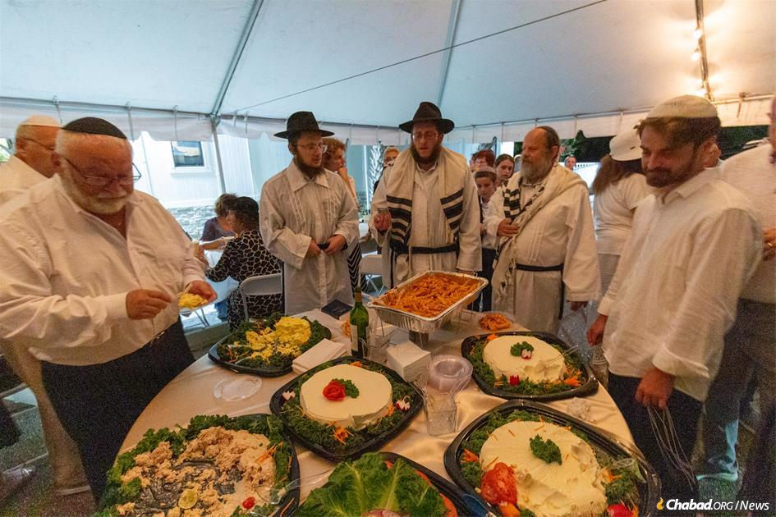
Rabbi Sholom Ber Schmerling makes havdalah after the conclusion of the Day of Atonement. (Credit: Chabad.org/Tzemach Weg)

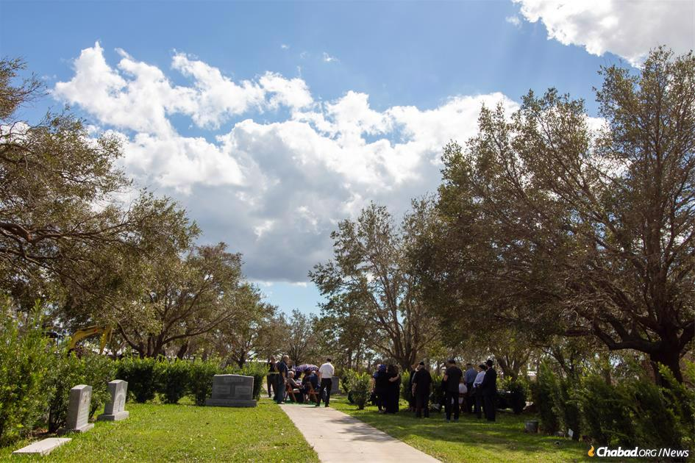
The next day, Rabbi Schmerling officiated at a funeral. (Credit: Chabad.org/Tzemach Weg) Reprinted from the current Chabad.Org website.
The Ticket or the Plane?
By Rabbi David Sutton

People constantly struggle to find the balance between the mitzvos of bitachon and hishtadlus — the effort they are required to put forth. We have trouble understanding how the efforts we undertake do not really cause the outcome, whether the issue is money or healing or anything else. We must be aware that the result is not our doing, but rather G-d’s decree. How do these seemingly opposing forces work together?
Chacham Ben Tzion Abba Shaul, in his sefer Ohr L’Tzion Chochmah U’Mussar, explains with an elegantly simple, on-point mashal: A person wants to reach a certain destination and needs to fly to get there. To be able to board the plane, he must first buy a ticket. Only then can he board. However, he knows very well that the ticket is not what brings him to his destination; rather, it is the plane.

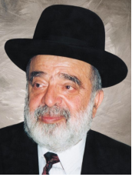
Chacham Ben Tzion Abba Shaul

The ticket does nothing at all to fuel or guide the plane. It is only a requirement for the passenger to embark. The airline has its rules, and we must follow them if we want a seat on the flight. Likewise, says Chacham Ben Tzion, G-d’s “airline” has its rules and regulations, which state that we must do our hishtadlus if we want to board the plane and get where He intends for us to go in life.
Once we board, however, our hishtadlus has done its job. It has no effect on the flight. Sometimes, a person keeps adding to his hishtadlus, but he doesn’t see results until he puts in one final bit of effort. Why is it so hard for him to get on the plane? Why the delay?
A couple was checking in to fly from Tel Aviv back to their home in New Jersey. They had gathered all the Covid test results and papers they needed to fly, but the clerk wanted to see proof of Covid vaccinations. Unaware that this would be necessary for their homeward flight, the man had stashed the document haphazardly in his luggage. He wasn’t sure where it was. Since he had been required to show it to enter Israel, he tried to reason with the clerk that there could be no doubt that he had it.
A Tense Fifteen Minutes
“Rules are rules,” she replied. Instead of passing through to the departure gate, the couple went off to the side to dig through their luggage and find the little laminated card that would gain them passage. It was a tense fifteen minutes until they calmed down and methodically unpacked the carry-on, where they at last found what they needed. They could go to the gate.
Like the vaccination card, sometimes hishtadlus seems frustrating and unnecessary. However, for whatever reason, this is what Hashem requires of us, and when we calm down and dig a little deeper, we achieve whatever it was He wanted us to achieve. But after all that, we still have to realize that it’s the plane, not the ticket, not the passport, not the Covid test result, that gets us where we need to go.
With this mashal, Chacham Ben Tzion also explains why there are great tzaddikim who receive their parnassah without hishtadlus. There are extreme examples of this, such as Rav Chaninah ben Dosa and Rav Shimon bar Yochai, to whom Hashem provided special ways of obtaining sustenance.

Those Who Don’t Need a Ticket
Even today, some of our gedolim seem to be sustained magically, directly by Hashem’s hand. Continuing with the airline mashal, those who need not “pay” hishtadlus are those who work for the airline. Imagine if someone were to ask the pilot, “How do you get from New York to Florida without a ticket? It’s impossible to fly without a ticket!”
He would answer that it is not at all impossible. The ticket doesn’t get him there, the plane does. He doesn’t need a ticket because he is among those who operate the airline. Likewise, the tzaddik helps Hashem run His creation. He is inseparable from Hashem and His Torah. Therefore, he can board free of charge, whereas ordinary people need to buy a ticket, and some tickets cost more than others.
In all cases, it’s the plane — G-d’s decree — that transports them. When you find yourself worn out or resentful of the work you must do to earn your living, think of all the good Hashem has given you and realize that this hishtadlus opened the door to all of it for you.

Reprinted from the Parshas Re’eh 5782 email of At The ArtScroll Shabbos Table. Excerpted from the ArtScroll book – “A Daily Dose of Bitachon” by Rabbi David Sutton.

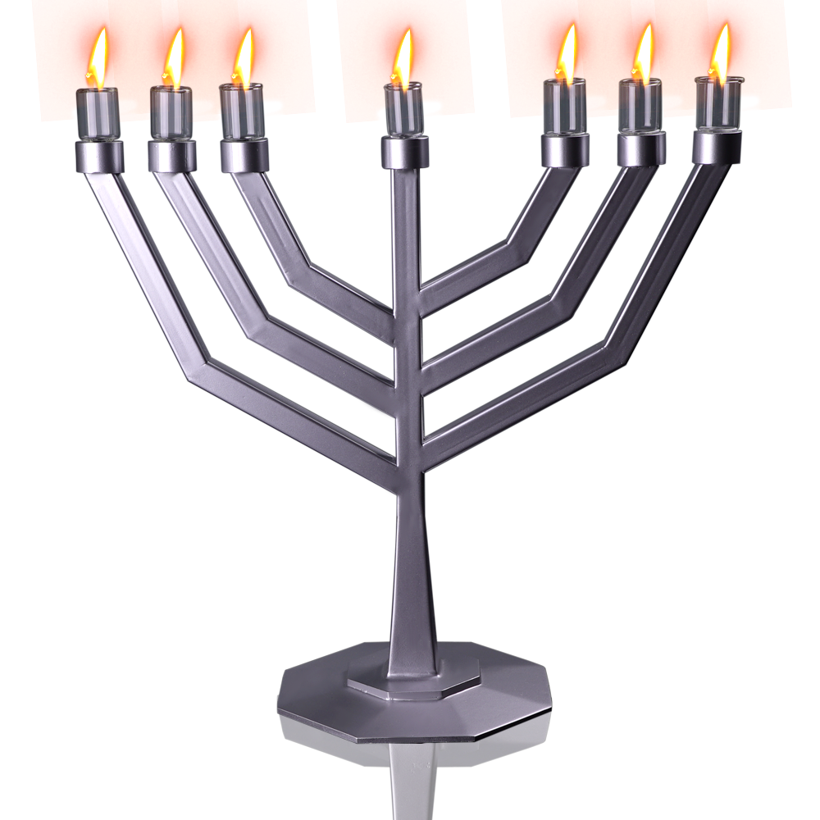

Contemporary Judaica Menorah designed by David Roytman.

